* **Activity 3:**

Using Group Functions in a Subquery

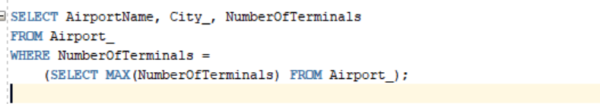

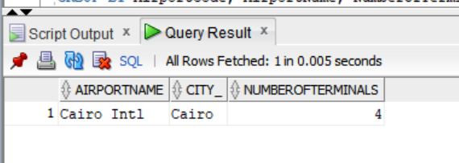OUTPUT: